Ysgol Gynradd Gymraeg
Y Login Fach

Gallaf lwyddo ond i mi roi cynnig arni!
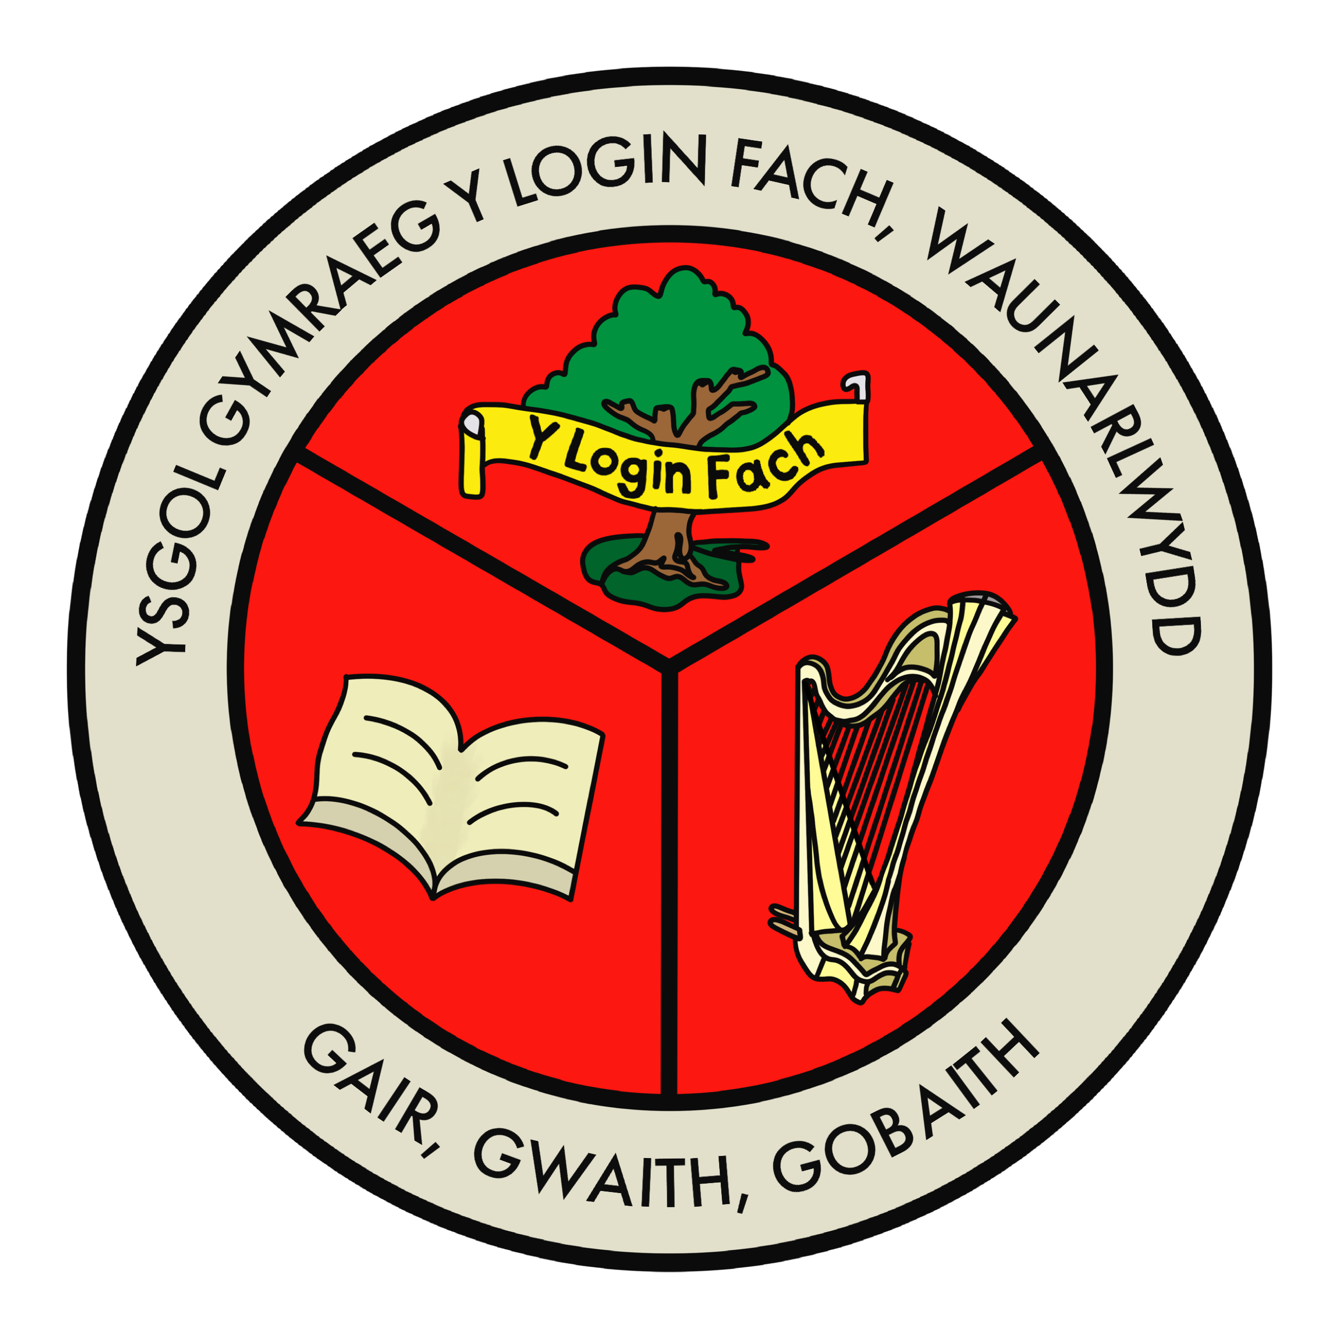

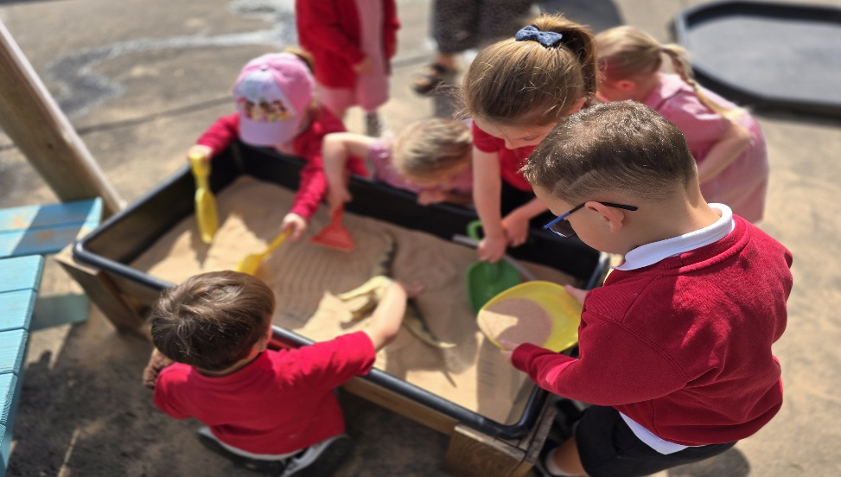

Llawlyfr Y Meithrin
Nursery Handbook

GAIR O GROESO

Annwyl Rieni / Gwarcheidwaid,
Croeso cynnes i Ysgol Gymraeg Y Login Fach. Gobeithio y bydd ein prosbectws yn ddefnyddiol ac y bydd yn eich annog i ddod i'n gweld yn yr ysgol.
Ein nod yw darparu ysgol 3-11 oed sy'n rhoi addysg cyfrwng Cymraeg o'r ansawdd uchaf mewn amgylchedd teg, cartrefol ac uchelgeisiol. Rydym yn credu mewn paratoi disgyblion trwy ddatblygu eu sgiliau a'u gwerthoedd wrth baratoi ar gyfer bywyd y tu hwnt i'r ystafell ddosbarth ac yn disgwyl wynebu heriau'r 21ain ganrif.
Rydym yn disgwyl y safonau uchaf posibl gan ein disgyblion ac rydym yn gwneud ein gorau glas i roi pob cyfle ac arweiniad iddynt. Mae pob disgybl yn cael ei ystyried yn unigolyn sy'n aelod pwysig o gymuned Ysgol Gymraeg Y Login Fach. Mae'r egwyddor sylfaenol hon o barchu pob unigolyn o fewn yr ysgol, a rhoi anghenion yr unigolyn yn ganolog i sail ethos, gwerthoedd a llwyddiant yr ysgol. Rydym yn hyderus bod ein disgyblion yn falch o'u hysgol, yn falch o'u Cymreictod a'u dwyieithrwydd, ac yn gallu cyfrannu at gymuned Waunarlwydd, Abertawe, Cymru a'r Byd.
Mae addysgu plant yn gyfrifoldeb mawr ac yn fraint enfawr. Os ydych chi'n rhiant i ddisgybl sydd eisoes yn yr ysgol, diolch am ymddiried ynddo. Mae gennym bolisi drws agored yma yn yr ysgol ac mae cydweithrediad rhieni a theuluoedd, a phartneriaith agos rhwng yr ysgol a’r cartref yn holl bwysig er mwyn cynnal y cyfleoedd gorau i’n plant.
Rydym yn ysgol sy’n parchu hawliau plant a chydnabyddwn fod gan bob un o dan 18 oed hawliau waeth beth [Erthygl 1 a 2 o Gonfensiwn y Cenhedloedd Unedig ar Hawliau’r Plentyn (CCUHP)].
Os ydych chi'n ystyried anfon eich plentyn i Ysgol Gymraeg Y Login Fach neu os hoffech wybod mwy, cysylltwch â ni a byddwn yn falch iawn o’ch tywys o gwmpas i chi brofi’r cyfeillgarwch a bwrlwm y dysgu ac addysgu.

Mrs Katrin Parkhouse
Pennaeth

A WORD OF WELCOME

Dear Parent or Guardian

A warm welcome to Ysgol Gymraeg Y Login Fach. I hope you find our prospectus useful and that it encourages you to come and visit us at the school.

Our aim is to teach children between 3-11 years old by preparing Welsh medium education of the highest standard in a fair, homely and ambitious environment. We believe in preparing our pupils for life beyond the classroom by developing their skills ensuring that they can face the challenges of the 21st century.

We expect the highest standards from our pupils and make every effort as a school to give them every possible opportunity and encouragement. Every pupil is treated as an individual and a valued member of the Ysgol Gymraeg Y Login Fach community. This fundamental principle of respecting every individual within the school, and putting the individual’s needs first is fundamental to the ethos, beliefs and success of the school. We are confident that our pupils are proud of their school, of their Welsh heritage and their bilingualism, and are able to positively contribute to the Waunarlwydd and Swansea communities, Wales and the world.

Providing your child’s education is a huge responsibility and a privilege. If you are a parent of a child who is already at the school, we thank you for entrusting your children to us. We have an open door policy here at the school and your co-operation as parents and families acting in partnership with us is invaluable in ensuring that your children are given the very best opportunities.

We are a school which respects the rights of children and we recognise that everyone under the age of 18 have rights [Article 1 & 2 of the United Nations Convention on the Rights of the Child - (UNCRC)

If you are considering sending your child to join us here at Ysgol Gymraeg Y Login Fach or if you would like to know more about us, please contact us and we will be more than happy to show you around the school so that you experience first-hand the friendly atmosphere and enthusiasm for teaching and learning.

Mrs Katrin Parkhouse
Headteacher

AMCANION YSGOL GYNRADD GYMRAEG Y LOGIN FACH

Nod yr ysgol yw creu awyrgylch hapus, diogel a chefnogol
- lle y caiff pob plentyn ei barchu a'i gydnabod fel unigolyn.
- lle y gall pob plentyn deimlo'n ddiogel o fewn awyrgylch gofalgar.
- lle y caiff pob plentyn gyfle cyfartal, heb wahaniaethu ar sail rhyw, hil na chrefydd.
- lle y gall pob disgybl fwynhau awyrgylch Gymraeg a Chymreig a lle y codir ymwybyddiaeth o Gymreictod a chariad at ein gwlad a chelfyddyd ein gwlad.
- lle y datblygir plentyn yn academaidd, yn emosiynol, yn ddiwylliannol, yn gorfforol, yn ysbrydol ac yn foesol.
- lle y datblygir hunanhyder, hunan-barch a pharch tuag at eraill,
- lle yr annogir sensitifrwydd, goddefgarwch at anghenion eraill o fewn a thu allan i'r ysgol.
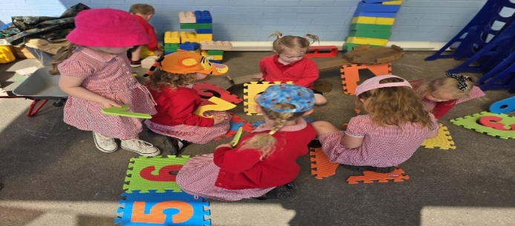

AIMS OF YSGOL GYNRADD GYMRAEG Y LOGIN FACH

The aim of the school is to create a happy, safe and supportive atmosphere
- where each child is respected and recognized as an individual.
- where every child can feel safe within a caring atmosphere.
- where all children have equal opportunities, without discrimination on the basis of sex, race or religion.
- where all pupils can enjoy a wholly Welsh atmosphere, where awareness of Welshness and love for our country and the art of our country are raised.
- where a child develops academically, emotionally, culturally, physically, spiritually and morally.
- where self-confidence, self-esteem and respect for others are developed,
- where sensitivity, tolerance to the needs of others within and outside the school is encouraged.

YR IAITH GYMRAEG

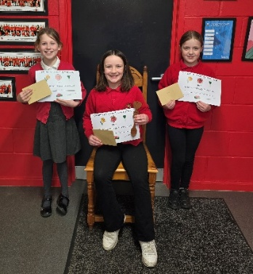
Iaith swyddogol yr ysgol yw'r Gymraeg a nod yr ysgol yw i bob plentyn fod yn rhugl ddwyieithog erbyn iddynt adael yr ysgol ar ddiwedd Blwyddyn 6. Cymraeg yw iaith y dosbarth a iaith y buarth.

Os yw plentyn di-Gymraeg yn ymuno â’r ysgol o Flwyddyn 1 fe wneir defnydd o’r ganolfan iaith a ddarperir gan y Sir.

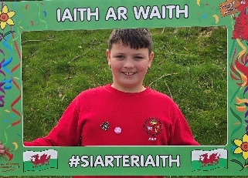
THE WELSH LANGUAGE

Welsh is the official language of the school and the aim of the school is for all children to be fluent bilingual by the time they leave school at the end of Year 6. Welsh is the language of the classroom and the language of the yard.

If a non-Welsh speaking pupil joins the school from Year 1, use will be made of the language immersion unit provided by the Local Authority.
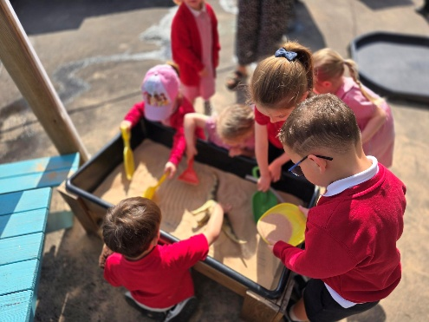

GOFAL BUGEILIOL

Y Pennaeth sy’n gyfrifol am drefniadaeth bugeiliol yr ysgol. Mae'r athrawon dosbarth yn ymwneud â gofal bugeiliol y disgyblion o fewn eu dosbarthiadau, ynghyd a’u lles a’u cynnydd addysgiadol.

Y Pennaeth yw’r person a enwir sy’n gyfrifol am y plant dan ofal yn yr ysgol a sydd yn sicrhau mewn ymgynghoriad a’r athro dosbarth bod cymorth priodol mewn lle.

PASTORAL CARE
The Headteacher is responsible for the pastoral organisation of the school. The class teachers are concerned with the pastoral care of the pupils within their classes, as well as their well-being and educational progress.

The Headteacher is the named person responsible for the children in care at the school who ensures in consultation with the district teacher that appropriate support is in place.

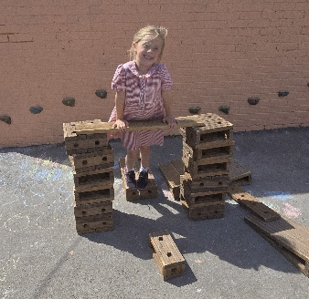

TREFNIADAU DERBYN EICH PLENTYN

Bydd plant yn cael eu derbyn i’r dosbarth Meithrin ar ôl eu penblwydd yn dair oed.

Y Dosbarth Meithrin | Cofrestrwch eich plentyn gyda’r ysgol cyn gynted a phosib.  Rydym yn cadw rhestr o’r plant sydd wedi cofrestru gyda ni.  Rhan amser.  Dosbarth Meithrin prynhawn yn y flwyddyn ysgol maent yn dair oed  Dosbarth Meithrin bore yn y flwyddyn maent yn 4 oed.
Y Dosbarth Derbyn | Cofrestru ar-lein gyda’r Awdurdod Lleol a byddant yn ystyried pob cais.  Cynigir lle i blant sydd yn byw o fewn y dalgylch.  Llawn amser.
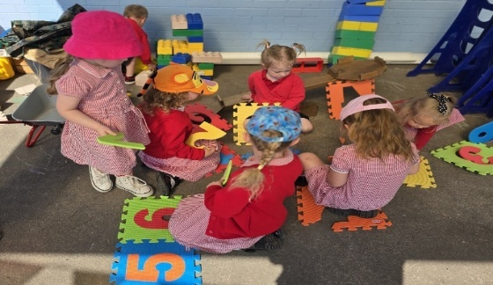
Every child has the right to an education and to attend school [Article 28 of the UNCRC]

Mae gan bob plentyn yr hawl i ddysgu a mynd i’r ysgol [Erthygl 28 o’r CCUHP)



ARRANGEMENTS FOR STARTING SCHOOL

Children can join the Nursery class after their third birthday.

Nursery | Register your child with the school as soon as possible.  We keep a list of children who will be joining the school when they are eligible.  Part time.  Afternoon Nursery class in the school year in which they turn three years old.  Morning Nursery in the school year in which they turn four years old.
Reception | Register online with the Local Authority and they will consider each application.  A place will be offered if you live within our catchment area.  Full time.

PARATOI EICH PLENTYN

Sut fedrwch chi helpu eich plentyn?

• anogwch eich plentyn i ddefnyddio’r tŷ bach yn annibynnol

• dysgwch eich plentyn i olchi ei dd/dwylo ac atgyfnerthwch hyn yn gyson fel ei b\fod yn cofio
gwneud hynny bob tro

• dysgwch eich plentyn i wisgo a dadwisgo ei g/chôt yn annibynnol

• anogwch eich plentyn i dacluso ac i ofalu am deganau.
Yn ogystal, bydden ni’n gwerthfawrogi’n fawr pe baech chi’n medru:

• trafod â’ch plentyn yr hwyl a’r sbri a geir yn yr ysgol

• helpu eich plentyn i adnabod ei enw

• darllen llyfrau a gwylio rhaglenni Cymraeg gyda’ch plentyn mor aml â phosibl (Cyw/Apiau Cymraeg)

• rhoi cyfle i’ch plentyn ddefnyddio offer creadigol gartref e.e. creonau, pensiliau, papur, glud, siswrn a phaent.

PREPARING YOUR CHILD

How can you help your child?

• encourage your child to use the toilet independently

• teach your child to wash their hands independently and reinforce this regularly

• teach your child how to wear their coat and remove their coat independently

• encourage your child to tidy up and respect toys and equipment.

In addition, we would greatly appreciate if you were able to:

• discuss with your child the fun to be found at school

• help your child recognise their name

• read books and watch Welsh language programmes with your child as often as possible (Cyw/Appiau Cymraeg)

• give your child the opportunity to use creative tools at home e.g. crayons, pencils, glue, paper, paint and scissors

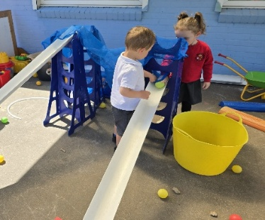
DIWRNOD CYNTAF EICH PLENTYN YN YR YSGOL

Bydd angen:

• gwisg ysgol (rhowch enw ar bopeth!)

- dim gemwaith

• bag ysgol bach i gario’r pethau isod:

- ffrwyth neu lysiau (dim cnau) mewn bocs gyda’i
h/enw arno Os ydych yn darparu grawnwyn,
bydd angen eu torri yn hanner, ar eu hyd, yn barod.

- diod o ddŵr mewn potel plastig gydag enw arni

- dillad sbâr.

Mae diwrnod cyntaf eich plentyn yn yr ysgol yn un i’w drysori, ac fe wnawn bob ymdrech i wneud yn siŵr ei fod yn un hapus a chofiadwy i bawb. Bydd plant y Meithrin yn dechrau fesul dipyn, a hynny er mwyn rhoi cyfle iddynt ymgartrefu ac ymgyfarwyddo â wynebau newydd yn ogystal â’u hamgylchedd dysgu newydd. Bydd hefyd yn gyfle gwerthfawr i rieni a staff ddod i adnabod ei gilydd.
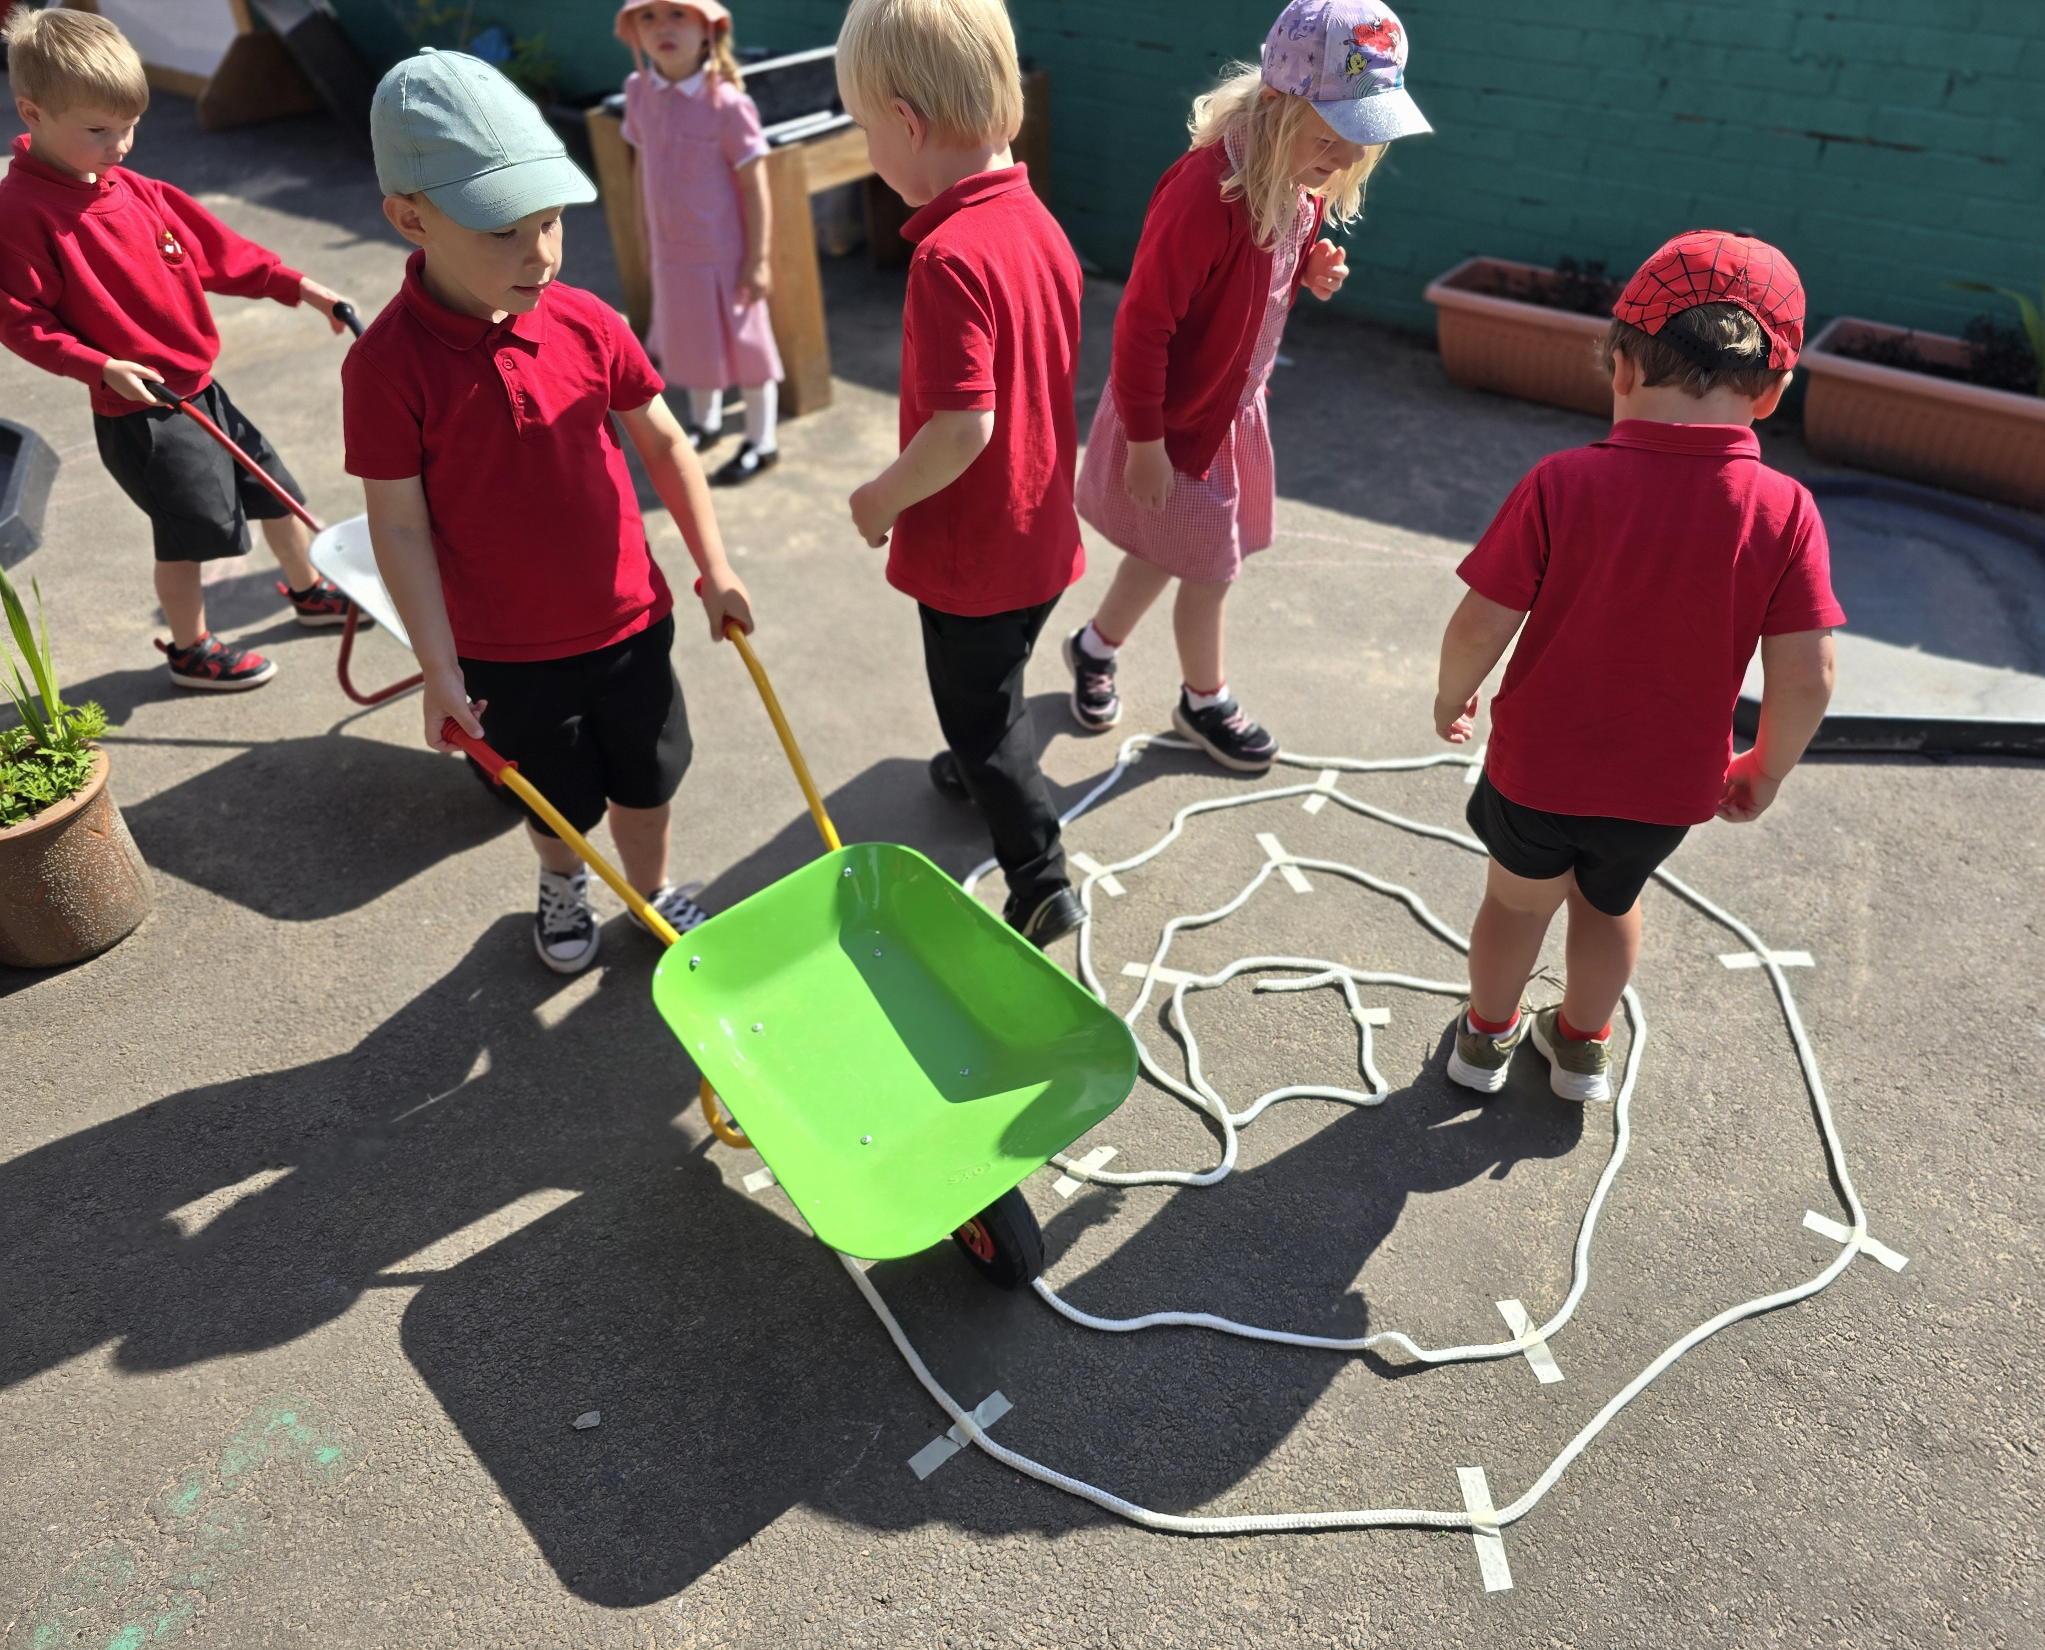
Does dim rhieni yn dod i’r safle ar ddechrau’r dydd ysgol ond yn ystod yr wythnosau cyntaf, mae croeso i chi dywys eich plentyn i’r dosbarth Meithrin ar hyd y llwybr cerdded, lle bydd aelodau staff yno i’ch cyfarch a’ch helpu. O fewn ychydig wythnosau, bydd eich plentyn yn ddigon hyderus i gerdded ar hyd y llwybr cerdded gyda’r plant eraill. Mae staff yr ysgol wedi eu lleoli ar hyd y llwybr er diogelwch a bydd yr athrawes ddosbarth ynghyd â chynorthwywyr y dosbarth ar gael i arwain eich plentyn i’r ystafell ddosbarth.

Gofynnwn eich bod yn ffarwelio’n hapus â’ch plentyn. Mae’n bosib
y bydd rhai plant yn ddagreuol wrth i rieni eu gadael am y tro cyntaf,
ond digon buan y dônt i’r arfer â ffarwelio. Os teimlwn fod eich
plentyn yn parhau i ofidio ar ôl cyfnod o amser, cysylltwn ni â chi.
Pan fyddwch yn casglu eich plentyn ar ddiwedd y sesiwn,
gofynnwn eich bod yn aros tu allan i brif fynedfa’r Feithrin. Byddwn
yn trosglwyddo plant yn ddiogel i’w rhiant / gwarcheidwad bob yn un.

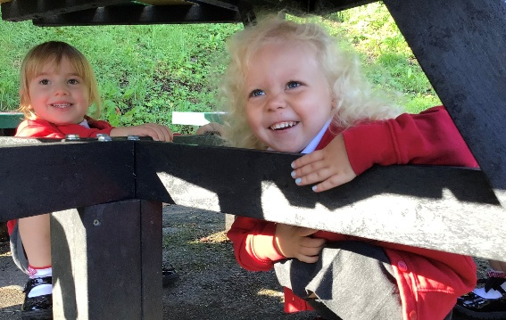

YOUR CHILD’S FIRST DAY IN SCHOOL

Your child will need:

- school uniform (name on everything!)

- a small school bag to carry the things listed below!

  - fruit or vegetables (no nuts) in a box with his/her name on it. If you are providing grapes, please ensure they are cut in half, lengthways.

  - water in a plastic bottle with your child’s name on it

  - no jewellery

  - spare clothes.

Your child's first day at school is one to cherish, and we will make every effort to make sure it is a happy and memorable one for everyone. The children of the Nursery will start gradually, in order to give them the opportunity to settle in and familiarize themselves with new faces as well as their new learning environment. It will also be a valuable opportunity for parents and staff to get to know each other.

Parents do not come onto the site at the start of the school day but during the first few weeks, you are welcome to take your child to the Nursery class along the footpath, where members of staff will be there to greet and help you. Within a few weeks, your child will be confident enough to walk along the walking path with the other children. School staff are stationed along the route for safety and the classroom teacher along with classroom assistants will be available to guide your child into the classroom.

We ask that you say goodbye ‘happily’ to your child. Some children may be tearful when parents leave them for the first time, but they get used to saying goodbye soon enough. If we feel that your child continues to worry after a period of time, we will contact you. When you collect your child at the end of the session, we ask that you wait outside the main entrance to the Nursery. We will transfer children safely to their parent/guardian one by one.

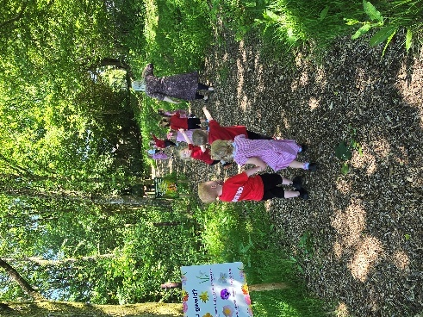
YSGOL GOEDWIG

Mae pob dosbarth yn ymweld a’n hardal goedwig yn wythnosol lle
mae pwyslais ar gynnig cyfleoedd arbennig i’n dysgwyr i ddatblygu
sgiliau megis hunan-ymwybyddiaeth, chwilfrydedd, empathi ac
annibyniaeth. Cânt y cyfle i godi eu hunanhyder a’u sgiliau
cyfathrebu trwy brofi gweithgareddau corfforol a chymdeithasol
amrywiol.

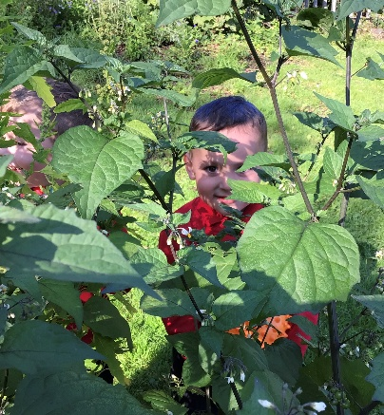
FOREST SCHOOL

Each class visits our forest area weekly where there is an emphasis on offering our learners special opportunities to develop skills such as self-awareness, curiosity, empathy and independence. They have the opportunity to raise their self-confidence and communication skills by experiencing various physical and social activities.

PHYSICAL EDUCATION

We encourage all pupils to live healthily and to take care of their bodies. Physical Education is an essential part of the curriculum and each class holds sessions during the week. Your child will need to wear their PE kit to school on the designated day.

ADDYSG GORFFOROL

Anogwn pob disgybl i fyw yn iach ac i ofalu am eu cyrff. Mae Addysg Gorfforol yn rhan hanfodol o’r cwricwlwm ac mae pob dosbarth yn cynnal sesiynau yn ystod yr wythnos. Bydd angen i’ch plentyn wisgo gwisg addysg gorfforol i’r ysgol ar y diwrnod penodedig.

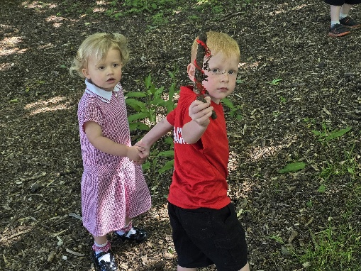

GWISG YSGOL

Mae gwisg ysgol yn hyrwyddo ymdeimlad o berthyn a balchder ac anogwn eich plentyn i wisgo gwisg swyddogol yr ysgol sef:

- trowsus / siorts du neu drowsus loncian du
- sgert ddu
- crys polo coch â logo’r ysgol
- siwmper ysgol goch gyda logo’r ysgol
- esgidiau du
- ffrog ‘gingham’ coch a gwyn yn yr haf
- sanau gwyn neu du gyda ffrog / sgert

Dylid marcio neu labelu pob dilledyn er mwyn osgoi ei golli.

Mae’r wisg ar gael o: JS Sports 74 Tycoch Road, Abertawe SA2 9EQ Tel: 01792 206658 www.theschooluniformshop.com

Oherwydd rhesymau iechyd a diogelwch, gofynnir i ddisgyblion i beidio â gwisgo gemwaith, megis modrwyon, mwclesi a breichledi. Pe bai’n angenrheidiol i wisgo clustlws/dlysau dros gyfnod penodol, yna dylid gwisgo ‘stud’.

Gofynwn hefyd i’r plant dorri eu gwalltiau yn synhwyrol ac osgoi lliwio gwallt neu chael patrymau cywrain wedi torri i’w gwallt. Ni chaniateir ewinedd hir / ffug am resymau iechyd a diogelwch.

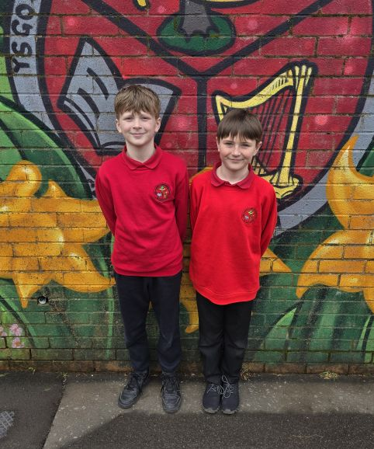
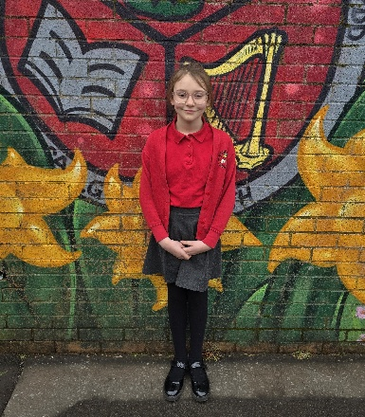
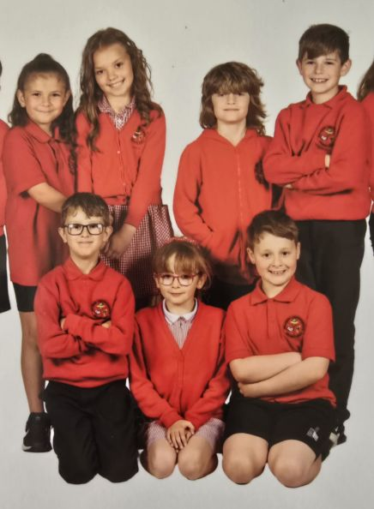
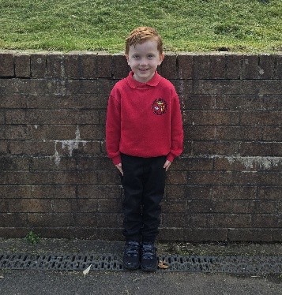
CLWB BRECWAST

Mae’r ysgol yn cynnig Clwb Brecwast dyddiol i blant y dosbarthiadau Meithrin bore, Derbyn a Blynyddoedd 1 i 6. Llywodraeth Cymru sy’n ariannu’r Clwb Brecwast.

Mae’r Clwb Brecwast yn agor am 8.10yb ac yn derbyn plant nes 8.25yb. Bydd y plant yn cael eu gorchuchwylio nes 8.40yb pan fyddant yn cael eu tywys i’r dosbarth.

BREAKFAST CLUB

The school offers a daily Breakfast Club for pupils in Morning Nursery, Reception and Years 1 to 6. This is financed by the Welsh Government.

The Breakfast Club opens at 8.10am, with last admission at 8.25am. The children are supervised until 8.40am when they are escorted to class.

SCHOOL UNIFORM

School uniform fosters a sense of belonging and pride and we encourage your child to wear the official uniform of:

- Black trousers / shorts or black jogging bottoms
- Black skirt
- Red polo shirt with school logo
- Red school sweatshirt with school logo
- Black shoes
- Red and white gingham dress in the summer
- White or black socks with dresses or skirts

All clothes need to be marked with your child’s name
so that lost items can be returned.

The uniform can be purchased at: JS Sports 74 Tycoch Road,
Abertawe SA2 9EQ Tel: 01792 206658 www.theschooluniformshop.com

For health and safety reasons, we ask that pupils do not wear jewellery such as rings, necklaces and bracelets. If it is essential to wear ear-rings for a specified period, ‘studs’ should be worn.

We also ask that the children have sensible haircuts and avoid colouring their hair or having patterns shaved into their hair. Fake nails are not permitted for health and safety reasons.

AMSERAU’R DYDD I’R MEITHRIN /

SCHOOL HOURS FOR THE NURSERY

Meithrin Bore / Morning Nursery 8.50 – 11.20

Meithrin Prynhawn / Afternoon Nursery 1.00 – 3.10

Os ydy eich plentyn yn hwyr yn cyrraedd yr ysgol, bydd angen dod i swyddfa’r ysgol er mwyn arwyddo bod eich plentyn wedi cyrraedd yn hwyr ac er mwyn i’ch plentyn gyrraedd y dosbarth.

If your child arrives late to school, you will need to come to the school office to sign them in as late arrivals and they will then be taken to their classroom .

TYMHORAU’R YSGOL A DYDDIADAU’R GWYLIAU AR GYFER 2025-2026
SCHOOL TERMS AND HOLIDAY DATES 2025-2026

Tymor / Term | Dechrau’r Tymor  Term Starts | Hanner Tymor  Half Term | Diwedd Tymor  End of Term
Tymor yr Hydref  Autumn Term | 1.9.2025 | 27.10.25 – 31.10.25 | 19.12.2025
Tymor y Gwanwyn  Spring Term | 5.1.2026 | 16.2.26 – 20.2.26 | 27.3.2026
Tymor yr Haf  Summer Term | 13.4.2026 | 25.5.26 – 29.5.26 | 20.7.2026

STAFF YR YSGOL
THE SCHOOL’S STAFF

Pennaeth / Headteacher | Mrs Katrin Parkhouse
Dirprwy Bennaeth / Deputy Headteacher | Mrs Rhian Davies
ALENCo / CADY | Mrs Denise Whitty
Athrawon / Teachers | Mrs Eleri Jones  Mrs Catrin Jones  Miss Siân Howells  Mrs Eiri Evans-Jones  Mrs Siân Morgan-Curran  Mr Aron Jones  Miss Angharad Thomas  Miss Katie Saunders  Miss Chloe Hopkins  Miss Megan Davies  Miss Ffion Davies
Cynorthwywyr Dosbarth / Teaching Assistants | Miss Julia Evans  Mrs Emma Sanderson  Mrs Mandy Vyse  Miss Lisa Badcock  Mrs Rhian Lynch  Mrs Emma Howells  Mrs Ann Rees-Sambrook  Mrs Diane Chapman  Mrs Ffiona Owen
Rheolwr Swyddfa / Office Manager | Mrs Rhian O’Brien

LLYWODRAETHWYR YR YSGOL
THE SCHOOL’S GOVERNING BODY

Cadeirydd / Chairperson: Mrs Susan Evans (Cymuned / Community)

Is Gadeirydd / Vice Chairperson: Dr Robert Hobbs (ALl / LEA)

Pennaeth / Headteacher: Mrs Katrin Parkhouse

Clerc / Clerk: Mrs Rhian O’Brien

Aelodau ar ran yr Awdurdod Lleol / Members on behalf of Local Authority:

Cyng / Cllr Wendy Smith
Mr Richard Edwards

Aelodau ar ran y Gymuned / Members on behalf of the Community:

Mr Derek Rees
Mrs Rachel Vallance

Rhiant Lywodraethwyr / Parent Governors:

Dr Kapilan Radhakrishnan
Mrs Siân Richards
Mr Christopher Davies
Dr Emma Chapman

Staff yr Ysgol / School Staff:

Mrs Rhian Davies
Mrs Mandy Vyse

